Project Design Phase-II

Data Flow Diagram & User Stories

|  |  |
| --- | --- |
| Date | 12-03-2025 |
| Team ID | PNT2025TMID06643 |
| Project Name | Power BI Inflation Analysis: Journeying Through Global Economic Terrain |
| Maximum Marks 4 Marks |  |

Data Flow Diagrams:

A Data Flow Diagram (DFD) is a traditional visual representation of the information flows within a system. A neat and clear DFD can depict the right amount of the system requirement graphically. It shows how data enters and leaves the system, what changes the information, and where data is stored.

* DFD LEVEL 0

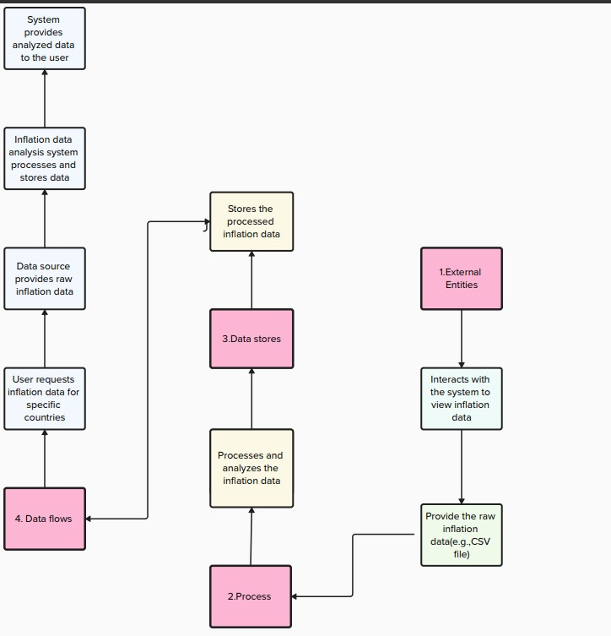

* User Stories:-

|  |  |  |  |  |
| --- | --- | --- | --- | --- |
| ID | USER STORY | ROLE | ACTION | BENEFIT |
| 1 | As a data engineer, I want to ingest inflation data from the CSV file. | Data Engineer | Ingest inflation data from the CSV file | So that the system can process and analyze the data. |
| 2 | As a data analyst, I want to clean the inflation data. | Data Analyst | Clean the inflation data (e.g., handle missing values, format data). | So that the data is consistent and ready for analysis. |
| 3 | As a database administrator, I want to store cleaned inflation data in a DB. | Database  Administrator | Store cleaned inflation data in a database. | So that it can be easily queried and analyzed. |
| 4 | As a user, I want to query inflation data for specific countries. | User | Query inflation data for specific countries (e.g., Afghanistan, Albania). | So that I can get inflation data for the countries I am interested in. |
| 5 | As a user, I want to query inflation data for specific years. | User | Query inflation data for specific years (e.g.,  2020, 2021). | So that I can analyze inflation trends for specific years. |
| 6 | As a user, I want to view inflation trends over time for a specific country. | User | View inflation trends over time for a specific country. | So that I can understand how inflation has changed over the years. |
| 7 | As a user, I want to compare inflation rates between multiple countries. | User | Compare  inflation rates between multiple countries. | So that I can identify patterns or differences in inflation rates. |
| 8 | As a user, I want to visualize inflation data using charts and graphs. | User | Visualize inflation data using charts and graphs. | So that I can easily interpret the data and draw insights. |